**Assignment 5.1**

1. **Top 5 employees (employee id and employee name) with highest rating**. (In case two

employees have same rating, employee with name coming first in dictionary should get

preference)

**grunt>** emp_with_rating = LOAD '/home/acadgild/pig/employee_details.txt' USING PigStorage(',') AS (emp_id:int, emp_name:chararray, emp_salary:int, emp_rating:int);

**grunt>** DUMP emp_with_rating;

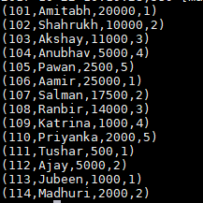

**grunt>** order_emp_name_rating = ORDER emp_with_rating by emp_rating desc, emp_name asc;

**grunt>** DUMP order_emp_name_rating;

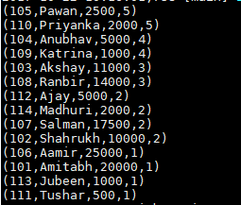

**grunt>** limit_top_5_emp_with_rating =LIMIT order_emp_name_rating 5;

**grunt>** DUMP limit_top_5_emp_with_rating;

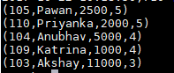

**grunt>** top_5_emp_with_rating = FOREACH limit_top_5_emp_with_rating GENERATE emp_id,emp_name;

**grunt>** DUMP top_5_emp_with_rating;

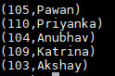

1. **Top 3 employees (employee id and employee name) with highest salary, whose employee id is an odd number.** (In case two employees have same salary, employee with name coming first in dictionary should get preference)

**grunt>** emp = LOAD '/home/acadgild/pig/employee_details.txt' USING PigStorage(',') AS (emp_id:int, emp_name:chararray, emp_salary:int);

**grunt>** DUMP emp;

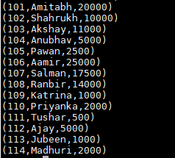

**grunt>** emp_odd_even_id = FOREACH emp GENERATE emp_id,emp_name,emp_salary, (

>> CASE

>> WHEN emp_id % 2 == 0 THEN 'even'

>> WHEN emp_id % 2 == 1 THEN 'odd'

>> END

>> ) AS odd_even;

**grunt>** DUMPemp_odd_even_id;

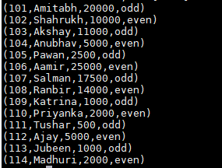

**grunt>** order_emp_odd_even_sal = ORDER emp_odd_even_id by odd_even desc,emp_salary desc;

**grunt>**DUMP order_emp_odd_even_sal;

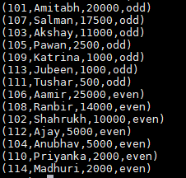

**grunt>** limit_top_3_odd_sal = LIMIT order_emp_odd_even_sal 3;

**grunt>**DUMP limit_top_3_odd_sal;



**grunt>** top_3_odd_sal = FOREACH limit_top_3_odd_sal GENERATE emp_id,emp_name;

**grunt>** DUMPtop_3_odd_sal;



1. **Employee (employee id and employee name) with maximum expense.** (In case two

employees have same expense, employee with name coming first in dictionary should get preference)

**grunt>** emp = LOAD '/home/acadgild/pig/employee_details.txt' USING PigStorage(',') AS (emp_id:int, emp_name:chararray, emp_salary:int);

**grunt>** emp_expenses = LOAD '/home/acadgild/pig/employee_expenses.txt' AS (emp_id:int, expenses:int);

**grunt>** joined_emp_data = join emp by emp_id , emp_expenses by emp_id;

**grunt>**DUMP joined_emp_data;

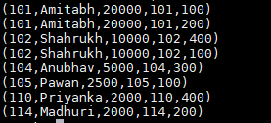

**grunt>** order_emp_expenses = ORDER joined_data by emp_expenses::expenses desc,emp::emp_name asc;

**grunt>** DUMP order_emp_expenses;

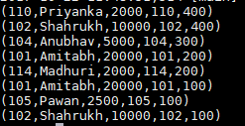

**grunt>** limit_emp_with_top_expns = LIMIT order_emp_expenses 1;

**grunt>**DUMP limit_emp_with_top_expns;



**grunt>** emp_with_top_expns = FOREACH emp_with_top_expns GENERATE emp::emp_id,emp::emp_name;

**grunt>** DUMP emp_with_top_expns;



1. **List of employees (employee id and employee name) having entries in employee_expenses file.**

**grunt>** emp = LOAD '/home/acadgild/pig/employee_details.txt' USING PigStorage(',') AS (emp_id:int, emp_name:chararray, emp_salary:int);

**grunt>** emp_expenses = LOAD '/home/acadgild/pig/employee_expenses.txt' AS (emp_id:int, expenses:int);

**grunt>** joined_emp_data = join emp by emp_id , emp_expenses by emp_id;

**grunt>** DUMPjoined_emp_data;

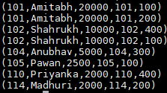

**grunt>** emp_with_entries_expenses = FOREACH joined_emp_data GENERATE emp::emp_id,emp::emp_name;

**grunt>**  DUMP emp_with_entries_expenses;

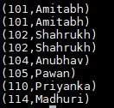

**grunt>** distinct_emp_with_entries_expenses = DISTINCT emp_with_entries_expenses;

**grunt>**  DUMP distinct_emp_with_entries_expenses;

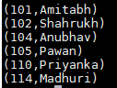

1. **List of employees (employee id and employee name) having no entry in employee_expenses file.**

**grunt>** emp = LOAD '/home/acadgild/pig/employee_details.txt' USING PigStorage(',') AS (emp_id:int, emp_name:chararray, emp_salary:int);

**grunt>** emp_expenses = LOAD '/home/acadgild/pig/employee_expenses.txt' AS (emp_id:int, expenses:int);

**grunt>** joined_emp_data = join emp by emp_id left outer, emp_expenses by emp_id;

**grunt>** DUMP joined_emp_data;

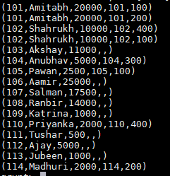

**grunt>** DUMP filter_emp_expenses;

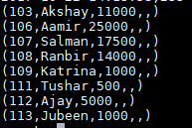

**grunt>** emp_not_in_expenses = FOREACH filter_emp_expenses generate $0,$1;

**grunt>** DUMP emp_not_in_expenses;

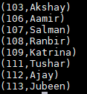

**grunt>** distnct_emp_not_in_expenses = DISTINCT emp_not_in_expenses;

**grunt>** dump distnct_emp_not_in_expenses;

